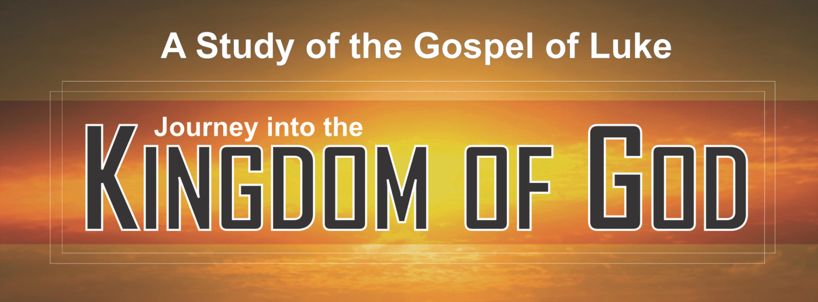

King James Version
Edition

Jeremy C. Higle
&
Tommy C. Higle

Other Bible Studies by Tommy C. Higle:

Journey Of A Lifetime (A 52-lesson survey of the entire Bible)
Journey From the Beginning, Revised (A 13-lesson study of Genesis 1-11)
Journey Into Purpose (A 13-lesson study of the life of Abraham)
Journey Into Victorious Living (A 13-lesson study of the life of Joseph)
Journey Into Intimacy With God, Revised (A 13-lesson study of the life of Moses)
Journey Into Righteous Living (A 13-lesson study of the Ten Commandments)
Journey Into True Worship (A 13-lesson study of the Tabernacle)
Journey Into Fearless Living (A 13-lesson study of Joshua)
Journey Through Adversity (A 13-lesson study of Job)
Journey Into God’s Applause, Revised (A 13-lesson study of the life of David)
Journey From Despair To Delight (A 13-lesson study of selected Psalms)
Journey Into Living Wisely In A Foolish World (A 13-lesson study of selected Proverbs)
Journey Into Meaningful Living (A 13-lesson study of Ecclesiastes)
Journey Into Renewal, Revised (A 13-lesson study of Nehemiah)
Journey Into Knowing God, Revised (A 13-lesson study of the names of God in the Old Testament)

Journey To The Cross (A 26-lesson study of the four Gospels)
Journey with the Messiah (A 52-lesson study of the gospel of Matthew)
Journey Into Experiencing the Power of Jesus (A 26-lesson study of the gospel of Mark)
Journey Into Knowing Jesus (A 26-lesson study of the gospel of John)
Journey Into Powerful Living (A 13-lesson study of the life of Peter)
Journey From Religion To Relationship (A 13-lesson study of the life of Paul)
Journey Into Changing the World (A 26-lesson study of Acts)
Journey Into Living God’s Way (A 26-lesson study of Romans)
Journey Into Biblical Problem Solving (A 26-lesson study of 1 Corinthians)
Journey Into Building Better Relationships (A 13-lesson study of 1 Corinthians 13)
Journey Into Liberated Living (A 13-lesson study of Galatians)
Journey Into Spirit-filled Living (A 13-lesson study of Ephesians)
Journey Into Stress-free Living (A 13-lesson study of Philippians)
Journey Into Becoming All God Wants You To Be (A 13-lesson study of Colossians)
Journey Into Defeating Discouragement (A 13-lesson study of 1 Thessalonians)
Journey Into Steadfast Living (A 13-lesson study of 2 Thessalonians, 2 John, and 3 John)
Journey Into Living the Gospel (A 13-lesson study of 1 Timothy)
Journey To A Faithful Finish, Revised (A 13-lesson study of 2 Timothy)
Journey Into the Good Life (A 13-lesson study of Titus and Philemon)
Journey Into Confident Living (A 26-lesson study of Hebrews)
Journey Into Pleasing God, Revised (A 13-lesson study of Hebrews 11)
Journey Into Faith That Works (A 13-lesson study of James)
Journey Into Triumphant Living (A 13-lesson study of 1 Peter)
Journey Into Becoming An Authentic Christian (A 13-lesson study of 2 Peter and Jude)
Journey Into Becoming A Contagious Christian (A 13-lesson study of 1 John)
Journey Through Revelation (A 26-lesson study of Revelation)

Journey Into Discipleship (A 26-lesson study of the basics of the Christian faith)
Deepening Your Spiritual Roots (A 7-lesson booklet for new believers)
Journey Through Spiritual Boot Camp (A 13-lesson basic training for the Christian life)
Deepening Your Spiritual Roots For Kids (A 6-lesson new believer booklet for children)

Journey Into Following Jesus (A 13-lesson study of the twelve disciples)
Journey Into Blessed Living (A 13-lesson study of the Beatitudes)
Journey Into Powerful Prayer (A 13-lesson study of the Lord’s Prayer)
Journey Into Christlikeness (A 13-lesson study of the fruit of the Spirit)
Journey Into Overcoming, Rising Above Life’s Toughest Problems (A 13-lesson study of life’s problems)
Journey To Your Spiritual Gift, Revised (A 13-lesson study of spiritual gifts)
Journey Into The Spirit World, Revised (A 13-lesson study of the spirit world)
Journey Into The Spirit World, Revised, Student Edition (A 7-lesson youth study of the spirit world)
Journey Into Kingdom Living (A 13-lesson study of the parables)

Journey Into Oneness (A premarital counseling guide)
Journey To A Maximum Marriage (A counseling guide for married couples)
Journey Into Debt-free Living (A 6-lesson study on personal finance)
Journey Into Church Membership (A 4-lesson basic study for Baptist churches)
Journey Into Believer Building (A 7-lesson study of the “one anothers” in the New Testament)
Journey To The New Jerusalem (A 7-lesson study of the Second Coming of Christ)

Journey into the Kingdom of God
(KJV Edition)
Copyright© 2021 by Tommy Higle Publishers, Inc. and its licensors. All rights reserved. No part of this book may be reproduced in any manner whatsoever, except for brief quotations in printed reviews, without the prior written consent of the publisher.
The Journey Series®
P. O. Box 416
Marietta, OK 73448
1-800-635-5346

order@JourneySeries.com

Visit Our Website:

www.JourneySeries.com

ISBN 978-1-948086-23-3 (Spiralbound)
ISBN 978-1-948086-24-0 (Loose-leaf)

Printed in the United States of America by Tommy Higle Publishers, Inc.
Original Drawings by Gerald Stone, Denton, TX
Cover Design by Jeremy Higle

Scripture quotations in this book are from the King James Version of the Bible.

The Journey Series® is the registered trademark of Tommy Higle Publishers, Inc.
Preface

Dear fellow lovers and learners of God’s Word,

The publishing process of this book was truly an arduous journey. I began the writing process just before the beginning of the pandemic of 2020. Like many businesses, we rode the Covid-19 rollercoaster of multiple quarantines, paid furloughs for our team members, masks, social distancing, delays from shipping companies, and eventually vaccinations. Then, just when things seemed to approach normal, a two-week winter storm paralyzed our area. However, as this book is being released, we are finally beginning a “normal” summer. I know we will appreciate it like none before.

I must also celebrate that this book marks the completion of one of my late father’s life goals—to complete a “Journey” Bible study on every book in the New Testament. This only took forty years of diligent work!

As always, this book is a team project. Thanks to my mom (Virginia), a former English teacher and now administrator and editor-in-chief of The Journey Series®. Special thanks also goes to the efficient staff (and my wonderful friends) at the Journey House: Martha Greenwood, Carolyn Gordon, Patti Donaldson, Ashly Martin, and the Higle boys (Joseph and Titus) who do the proofreading, binding, packaging, order processing, shipping, answering of phones, and hundreds of other things.

A very special thanks goes to my wife Pamela, a high school English teacher and my loving partner for 24 years of adventures (and counting).

Most of all, I want to thank the Lord for giving me the wonderful privilege of teaching and preaching His inspired, written Word. Whatever comes in the next years, His Word and His Ways will always be true and faithful.

Peace and hope,

Jeremy Higle
The Journey House
6/4/2021

Suggestions for Your Journey

- Helpful Materials

1. A good study Bible and reliable Bible dictionary (Ask your pastor or teacher for help in this area.)

2. A lead pencil. Don’t use ink because you may want to change your answers.

II. Hints for Personal Study

1. Pray for God’s guidance before each session, that your mind and heart will be receptive to God’s message for you.

2. Don’t worry about scriptures you do not understand. Simply concentrate on what God reveals to you in His Word for now, and trust Him to make the vague things clearer as you continue to study.

3. Mark the Bible verses that really speak to you.

4. Read each lesson at least three times each week.

III. How To Get the Most Out of Your Class Time

1. Attend every class period.

2. Arrive at least 10 minutes early to look over the lesson, so you will have an idea of what will be covered during that session.

3. Write down things you want to remember, or you will probably forget them. You increase your retention by 300% if you take notes.

4. Pray for your teacher every day.

IV. How To Answer the Questions in the Lessons

1. Look up the scripture reference in your Bible. Usually the answer is very simple and clear in that reference. However, sometimes there are questions that require thought, so you must meditate over the verse or passage to find its meaning. Answering the questions will become easier as the Bible comes to life to you during the study.

2. Don’t simply quote the scripture. Write it in your own words as briefly as possible.

3. Whenever possible, personalize the scripture by using pronouns such as “I,” “me,” “my,” “mine,” etc.

Table of Contents

Spiritual Preparation for Your Journey 6
Lesson 1 . . . Preparing the Way of the Lord (1:1-56) 7
Lesson 2 . . . Partnering in the Work of the Lord (1:57-2:20) 11
Lesson 3 . . . Can We Trust the Stories About Jesus? (2:21-52) 17
Lesson 4 . . . Three Callings When the King Arrives (3:1-38) 21
Lesson 5 . . . Responding to Temptation and Rejection (4:1-44) 25
Lesson 6 . . . How Jesus Deals with Sinners (5:1-39) 29
Lesson 7 . . . The King Describes His Kingdom (6:1-49) 33
Lesson 8 . . . The King’s Perfect Timing (7:1-50) 37
Lesson 9 . . . The King Prepares Us for Ministry (8:1-56) 41
Lesson 10 . . . How To Participate in Kingdom Work (9:1-62) 45
Lesson 11 . . . How To Serve Our King with Gladness (10:1-42) 49
Lesson 12 . . . What Are Jesus’ Duties in the Kingdom? (11:1-54) 53
Lesson 13 . . . Four Secret Sins To Be Revealed by Our King (12:1-59) 57
Lesson 14 . . . Five Secret Truths the King Reveals (13:1-35) 61
Lesson 15 . . . How To Set Kingdom Priorities (14:1-35) 65
Lesson 16 . . . Understanding the Process of Salvation (15:1-32) 69
Lesson 17 . . . Building a Heavenly Treasure (16:1-31) 73
Lesson 18 . . . Avoiding Temptation Traps (17:1-37) 77
Lesson 19 . . . Four Powerful Possessions (18:1-34) 81
Lesson 20 . . . How King Jesus Builds His Kingdom (19:1-48) 85
Lesson 21 . . . How King Jesus Answers His Enemies (20:1-47) 89
Lesson 22 . . . Waiting for Our King’s Return (21:1-38) 93
Lesson 23 . . . How King Jesus Transformed History (22:1-38) 97
Lesson 24 . . . How To Deal with Desperate Times (22:39-71) 101
Lesson 25 . . . Why the King Became the Final Sacrifice (23:1-56) 105
Lesson 26 . . . How King Jesus Made All Things New (24:1-53) 111
List of Eyewitnesses Mentioned by Luke 116
Bibliography 118

Spiritual Preparation for Your Journey

To get the most from this “journey,” you must be spiritually prepared. The basic preparation is knowing Jesus Christ as Lord (boss) and Savior, so He can be your spiritual Guide on the journey. If you have never received Him, or if you are not sure, there are four things you must understand . . .

1. God loves you and wants you to have eternal life.

The Bible says, For God so loved the world that he gave his only begotten Son, that whosoever believeth in him should not perish, but have everlasting life (John 3:16*). The Bible also says, But God commendeth [proved] his love toward us, in that, while we were yet sinners, Christ died for us (Romans 5:8*).

2. You are sinful, and your sin separates you from God.

The Bible says, For all have sinned, and come short of the glory of God (Romans 3:23*). Sin separates us from God, for the Bible says, But your iniquities have separated between you and your God, and your sins have hid his face from you . . . (Isaiah 59:2*).

3. Only in Jesus Christ can forgiveness of sin and salvation be yours.

Jesus said, I am the way, the truth, and the life: no man cometh unto the Father, but by me (John 14:6*). You must believe God loved us so much He sent His Son Jesus Christ to die on the cross to provide the way of salvation and that on the third day, God raised Jesus from the dead (Rom. 10:9)

Right now you may be thinking, “I already believe these things.” Well, the Bible teaches it is not a matter of just believing, for the devils also believe, and tremble (James 2:19b*). Simply believing Adolf Hitler lived and died doesn’t make you a Nazi, and believing Jesus Christ lived and died doesn’t make you a Christian. You must act upon what you believe.

4. You must repent and receive Jesus Christ as Lord and Savior.

It is not enough to agree that Jesus Christ is the Son of God, who died on the cross for your sins and rose again. You must repent of your sins. Jesus said to be saved you must repent and believe the gospel (Mark 1:15*). Repent means to turn away from your selfishness and sin and turn control of your life over to Jesus Christ. If you sense your need to repent of your sins and be saved, that is the Holy Spirit drawing you to Christ. Jesus said no one can come to Him unless the Father draws him (John 6:44*).

If you will pray the following prayer right now, or pray in your own words, telling God you are repenting of your sins and inviting Jesus Christ into your heart, you can receive Him today as your Lord and Savior. The words are not as important as what you mean in your heart. Jesus said a man at the temple simply prayed, God be merciful to me a sinner and went to his house justified, or saved (Luke 18:13-14*).

Dear Lord,
I know I have sinned. Right now, I repent of my sins and ask for Your forgiveness. I ask Jesus to be my Lord, to control my life, and to help me become the person You want me to be. Thank You, Jesus, for dying on the cross so I could be forgiven. Amen.

Now, share your decision with your pastor or teacher.
*Scriptures from KJV

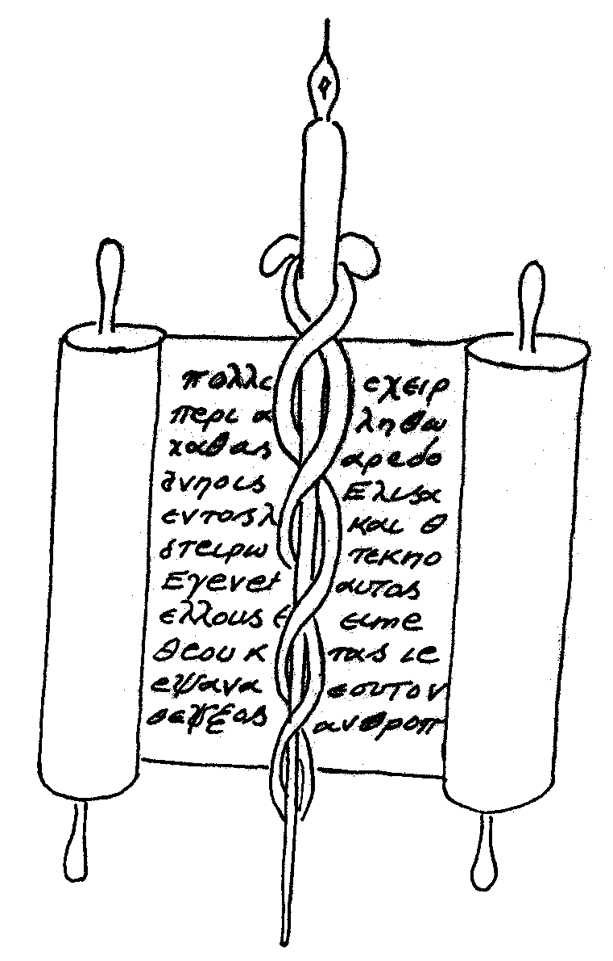Lesson 1 . . . Preparing the Way of the Lord (1:1-56)
Notes

L
uke was a Gentile⎯trained as a Roman physician, redeemed by Christ, inspired by the Holy Spirit, and set apart for ministry. That is all we know because Luke did not write about himself. Instead, he focused on the Glory of God as revealed in history through the words and works of Jesus Christ. This is the “Gospel According to Luke.”

Luke meticulously authored a two-part history of the church. The first part, The Gospel According to Luke, describes the life of Jesus Christ. The second part, The Acts of the Apostles, records the early years of Christianity. Luke did careful research—interviewing disciples, meeting family members, and collecting firsthand testimonies of events. He also personally witnessed many of the things he recorded in Acts. He had perfect understanding of all things from the very first (Lk 1:3b). Why does Luke write so carefully (1:4)?

____________________________________________________________

____________________________________________________________

Luke’s carefully researched, historical books declare the kingdom of God has entered into human history. The phrase “kingdom of God” occurs more than thirty times in Luke, more than the other three gospels combined. Luke wants people to know God’s kingdom is for Jews and Gentiles alike. From where do the citizens of the kingdom of God come, according to Jesus (Luke 13:29)?

___________________________________________________________

____________________________________________________________

Jesus calls people from every direction. Everyone who responds to His call receives three wonderful blessings: forgiveness of every sin, eternal life in heaven, and a purpose for daily living. In this lesson, we see how to prepare the way of the Lord in our lives. First. . .

Be faithful in the daily ministry God gives us to do (1:5-25).

Herod the Great was the Roman-appointed ruler of Judea. When the Romans conquered a foreign country, they allowed their subjects to continue practicing their religious traditions. As long as the Jewish people submitted to the laws and taxes of the Romans, they were permitted to continue most religious traditions of the Old Testament. These traditions were administered by thousands of Levitical priests living throughout Israel. Luke’s record begins with events in the lives of one of these priestly families.

A certain priest named Zecharias and his wife Elisabeth are well-advanced in years and have no children. This reminds us of Abraham and Sarah in the Old Testament. Though their hope of having children has passed, Zecharias and Elisabeth have continued to obey all the commandments and Jewish regulations. Luke describes them as walking. . . blameless because they are faithful in the daily ministry God has given them (1:5-7).

As it happens, Zecharias is chosen by lot to burn incense in the temple as a representative of his priestly division. Out of the thousands of priests all over the country, only a few received this once-in-a-lifetime opportunity. This would be the greatest honor of Zecharias’ priestly career (1:8-9).

As Zecharias executes his priestly tasks, an angel of the Lord appears to him on the right side of the altar of incense. Fear overcomes Zecharias. But the angel tells him, Fear not, Zecharias: for thy prayer is heard (1:13a). Like Abraham and Sarah from generations before, Zecharias and Elisabeth will have a son in their old age (1:13b).

The angel then announces a special name for their son: John. He will live a holy lifestyle—abstaining from alcohol and being filled with the Holy Spirit even from his mother’s womb (1:13c-15). Then, in verses 16-17, the angel explains John’s mission. John is the fulfillment of what prophecy in Malachi 3:1a?

____________________________________________________________

____________________________________________________________

Zecharias hesitates and then says to the angel: Whereby shall I know this? for I am an old man, and my wife well stricken in years (1:18). This reminds us of Moses’ experience at the burning bush. Moses questions God’s command and calling by saying: they will not believe me (Ex 4:1); I am slow of speech (Ex 4:10), and “please send someone else” (Ex 4:13). Zecharias and Moses hesitate because they think in terms of their limited human capabilities. However, God’s plans are based on His divine, limitless capabilities.

When God calls us to follow Him, we should remember what truth expressed in Psalm 20:7?

____________________________________________________________

____________________________________________________________

God knows about Moses’ and Zecharias’ immature faith when He chooses them. So, He immediately begins working to develop their faith. God uses “different strokes for different folks.” He brings Moses a helper to speak for him (Ex 4:14-15). However, God strikes Zecharias mute, so he cannot speak (1:20). Sometimes the Lord gives, and sometimes the Lord takes away. In each case, He knows the best means to bring about His good and perfect will, while strengthening the faith of His children.
While Zecharias encounters the angel, the people outside are wondering why he is taking so long to come out. When he finally exits the temple, he can’t verbalize what has happened. So, Zecharias invents some sort of sign language to explain the angelic encounter in the temple (1:21-22). (I would love to have witnessed that game of charades!)

After his time of serving in the temple, Zecharias returns home, still unable to speak (1:23). Probably in a written note, he evidently communicates the angelic announcement to Elisabeth. If you were to tell a barren woman in her sixties she is going to have a baby, what would be her reaction? I imagine Elisabeth’s response is a mixture of disbelief, fear, and joy. Like Abraham, Sarah, and Zecharias, Elisabeth has her reservations about God’s miraculous promise. But she hears the Word, responds with imperfect faith, and God proves faithful (1:24-25).

Why is it so important, even though our faith is imperfect, to seek God through faithful obedience, according to Hebrews 11:6?

____________________________________________________________

____________________________________________________________

____________________________________________________________

To prepare for the way of the Lord in our lives, be faithful in the daily ministry God gives us to do, and . . .

Be obedient when God calls us to something new (1:26-45).

In the sixth month of Elisabeth’s pregnancy, God sends Gabriel to Nazareth to visit a young woman named Mary (1:26-29). If Gabriel’s appearance scared a seasoned priest like Zecharias, trained in reading the holy scriptures and experienced in the temple rituals, it must have absolutely terrified a simple, uneducated village girl!

Gabriel comforts Mary (1:30) and tells her: . . . thou shalt conceive in thy womb and bring forth a son, and shalt call his name JESUS. He shall be great, and shall be called the Son of the Highest . . . and of his kingdom there shall be no end (1:31-33). Mary must have become as confused as she was terrified. Just like Moses and Zecharias, Mary questions God’s pronouncement: How shall this be, seeing I know not a man? (1:34b).

This does not make any human sense. Mary’s mind, body, and emotions all tell her one thing—this is impossible. Gabriel gives her some details and then makes a final statement. What does Gabriel tell her in 1:37?

____________________________________________________________

____________________________________________________________
Mary replies by saying she is the Lord’s handmaid (1:38a). The word translated handmaid is δούλη (doo´-lay), which literally means “female slave.” Though she is afraid and confused, Mary is obedient when God calls her to something new.

After the angel departs, Mary thinks of the one person who can empathize with her amazing and confusing experience—her older cousin Elisabeth. So, Mary goes with haste to the home of Elisabeth and Zecharias (1:39-40). What three things happen when Elisabeth hears the sound of Mary’s voice (1:41-42)?

1. __________________________________________________________

2. __________________________________________________________

3. __________________________________________________________

____________________________________________________________

To prepare the way for the Lord in our lives, be faithful in the daily ministry God gives us to do, be obedient when God calls us to something new, and . . .

Be thankful God is working in our lives (1:46-56).
Mary responds to Elisabeth by praising God’s favor on her and her people. Later church tradition would name this prayer “The Magnificat” after the first words of the prayer when translated into Latin. Write down the English translation of what Mary says in verse 46a on the line below:

____________________________________________________________

These passages demonstrate that God uses imperfect people to accomplish His perfect work. As we prepare for the way of the Lord in our lives, we don’t have to be perfect, but we must:

Be faithful in the daily ministry God gives us to do;
Be obedient when God calls us to something new; and
Be thankful God is working in our lives.

